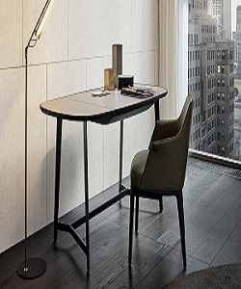

Poliform Study Table

$78.43

Availability: In stock

**Description:**

Seattle chair with light brown table. You can feel comfortable during study. This study table is made from good quality of wood and designed it with special light shape that make your room more beautiful. Have a look at Poliform’s range and you’ll find that the style you have always dreamt of actually exists. A design able to propose a primary form that enhances the naturalness of wood. Lightweight shapes interpreted with essential style.